**Advance Excel Assignment 6**

1. **What are the various elements of the Excel interface? Describe how they're used?**

The various elements of the Excel interface include:

* Workbook: A file that contains one or more worksheets for data organization and analysis.
* Ribbon: The horizontal toolbar at the top with tabs containing commands for different tasks like formatting, data manipulation, etc.
* Worksheets: Tabs at the bottom to switch between different sheets within the workbook.
* Columns and Rows: A grid of cells organized into columns (labelled with letters) and rows (labelled with numbers) to enter and analyse data.
* Formula Bar: Displays the content of the active cell and allows entering or editing formulas.
* Cell Reference: The unique identifier for each cell, consisting of the column letter and row number (e.g., A1, B3).
* Cell Contents: The data entered or displayed in a cell, including text, numbers, or formulas.
* Name Box: Displays the address or name of the selected cell.
* Status Bar: Provides information on the current mode, calculations, and other settings.
* Zoom Slider: Allows adjusting the zoom level for better viewing.

These elements are used for data entry, manipulation, analysis, and formatting tasks in Excel, enabling users to organize and process data efficiently.

1. **Write down the various applications of Excel in the industry.**

Various applications of Excel in the industry include:

* Data Analysis: Excel is used for data analysis, generating insights, and creating reports from large datasets.
* Financial Modelling: It is employed for financial analysis, budgeting, and forecasting in finance and accounting sectors.
* Project Management: Excel aids in project planning, tracking progress, and managing resources.
* Inventory Management: Excel helps businesses track inventory levels, reorder points, and manage stock efficiently.
* Sales and Marketing: It is utilized for sales data tracking, lead management, and marketing analytics.
* Human Resources: Excel is used for employee data management, payroll calculations, and HR analytics.
* Data Visualization: It creates charts and graphs to visually represent data for presentations.
* Customer Relationship Management (CRM): Excel can be used to manage customer data, contacts, and sales information.
* Quality Control: It aids in analysing product quality data and performing statistical analysis.
* Research and Analysis: Excel is widely used in research projects for data collection and analysis.

Overall, Excel's versatility makes it a valuable tool across industries for data management, analysis, and decision-making processes.

1. **On the ribbon, make a new tab. Add some different groups, insert commands in the groups and name them according to their commands added. Copy and paste the screenshot of the steps you followed.**

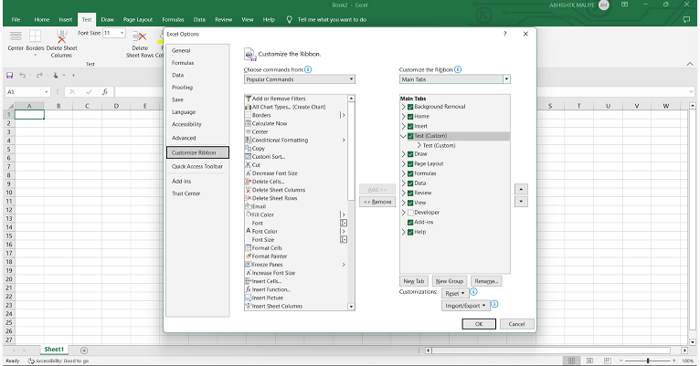

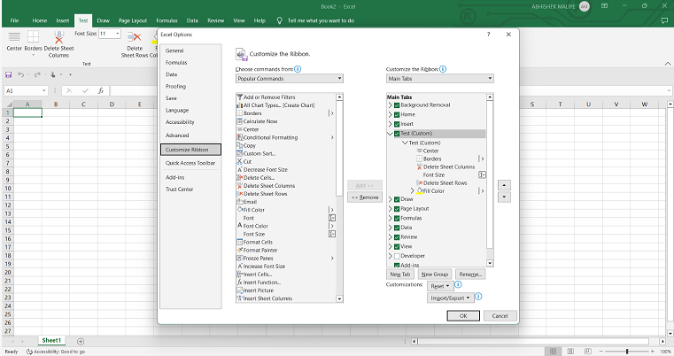Top of Form

1. **Make a list of different shortcut keys that are only connected to formatting with their functions.**

Here is a list of different shortcut keys in Excel that are specifically connected to formatting tasks:

* Ctrl + 1: Open the "Format Cells" dialog box.
* Ctrl + Shift + &: Apply the "Border" formatting to selected cells.
* Ctrl + Shift + _: Remove the "Underline" formatting from selected cells.
* Ctrl + Shift + $: Apply the "Currency" format to selected cells.
* Ctrl + Shift + %: Apply the "Percentage" format to selected cells.
* Ctrl + Shift + #: Apply the "Date" format to selected cells.
* Ctrl + Shift + @: Apply the "Time" format to selected cells.
* Ctrl + Shift + ~: Apply the "General" format to selected cells.
* Ctrl + Shift + !: Apply the "Number" format with two decimal places to selected cells.
* Ctrl + Shift + ^: Apply the "Scientific" format to selected cells.

1. **What distinguishes Excel from other analytical tools?**

Excel distinguishes itself from other analytical tools with its familiar user interface, versatility, accessibility, cost-effectiveness, customization options, interactive data visualization, collaboration features, and extensive learning resources. However, it may have limitations compared to more specialized tools in handling large datasets and advanced statistical analysis.

1. **Create a table and add a custom header and footer to your table.**

* Open Excel and create a table by selecting the data you want to include in the table.
* Go to the "Insert" tab on the Excel ribbon.
* Click on "Table" and choose a table style from the options.
* Excel will automatically add headers to the table based on the column names.
* To add a custom header, click on the header row and type your custom header names.
* To add a footer, go to the "Page Layout" tab on the Excel ribbon.
* Click on "Print Titles" in the "Page Setup" group.
* In the "Page Setup" dialog box, go to the "Header/Footer" tab.
* Enter your custom footer text in the "Footer" box.
* Click "OK" to apply the custom header and footer to your table.

This will create a table with a custom header and footer in Excel, enhancing the presentation and aesthetics of data.